Redmond_Ben_200412111_ Web Design & Development

CA_ONE

This project aimed to design a brochure website for a Bed & Breakfast Business in Galway City.  
  
I started with the website's overall design using Figma, making a wireframe and indicating where I wanted content and page layout.

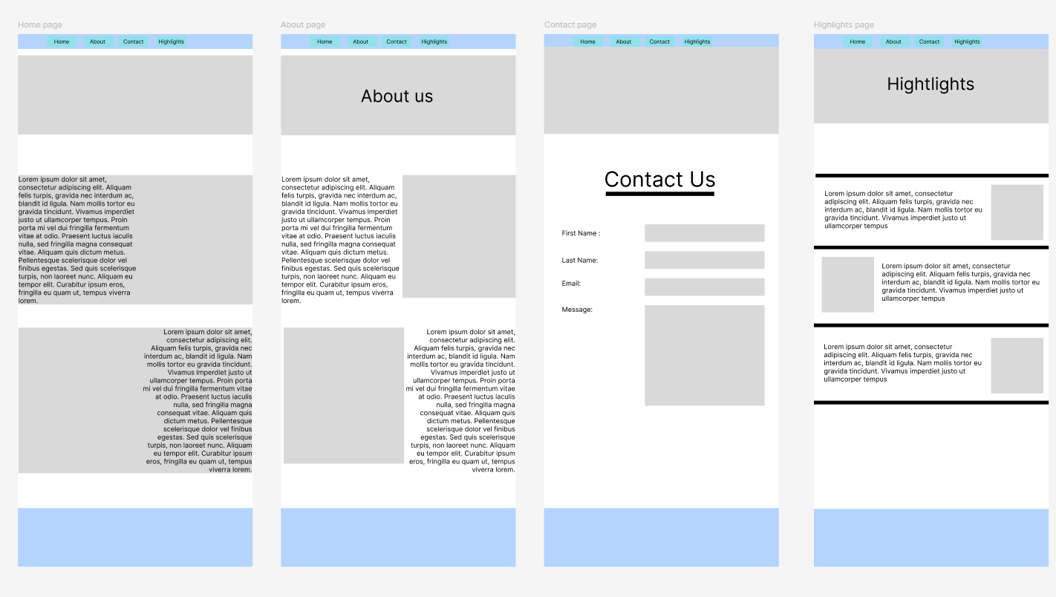

For this project, I started using GitHub Desktop. My work could be remote so I would have a quick way of updating what I was doing. Here is a link to my repo   
<https://github.com/BenRedmondgithub/20041211_Redmond_Ben_WebDev-project>

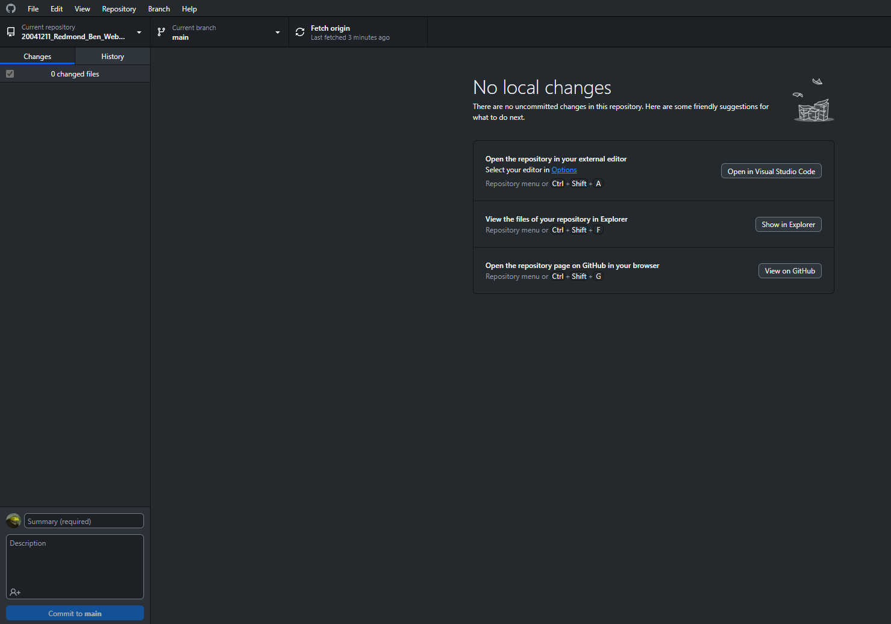

The very first thing I did was set up the Navbar with links to all the other pages the next was to create a div to hold the hero image and the H1 In place, the Navbar and the main text on screen using Merienda linked with Google fonts, here is a link to the font.

<https://fonts.google.com/specimen/Merienda?query=Merienda>

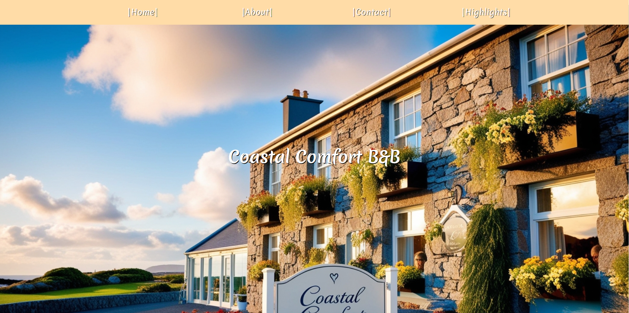

Then, I used the main tag and created two divs with text and two images, one image on the right with text on the left and the other the opposite way. It was a bit hard to understand how the images would work if you used float left and right.

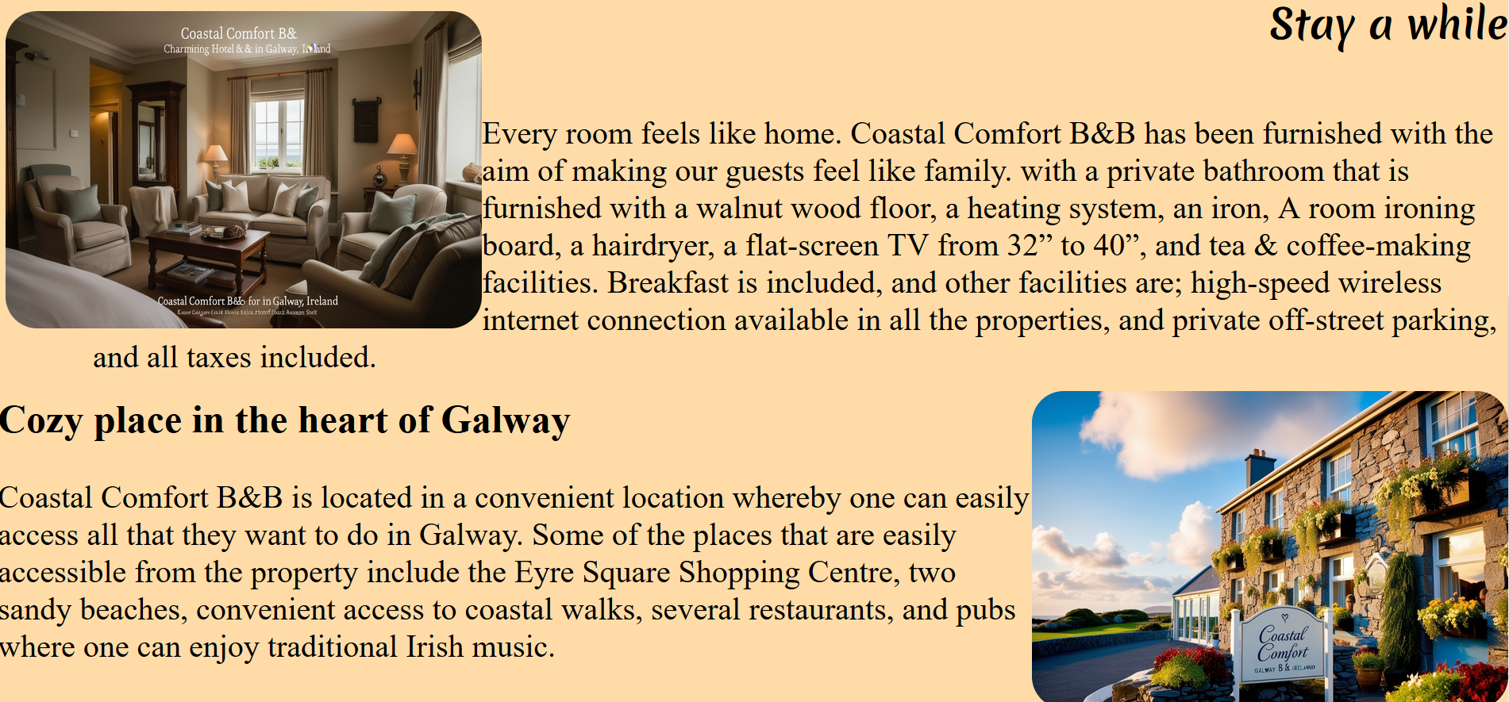

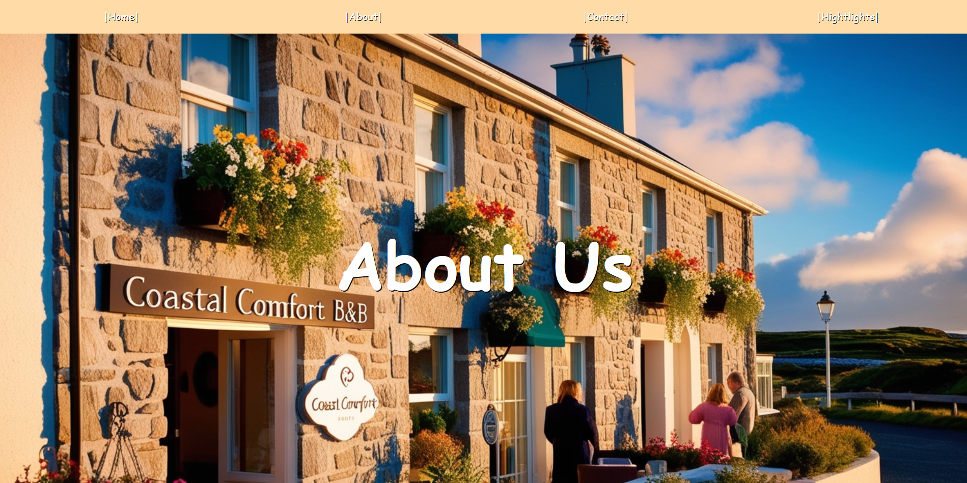

Then, I started the About Us page. This page is for the public to get to know the owners and how they are. However, this hero image is different from the main home page image. I started using background images in my CSS and put the background image within the first div. I found it hard to change the Homepage if the Hero image was in the first div. The background image helped me very much in that regard.

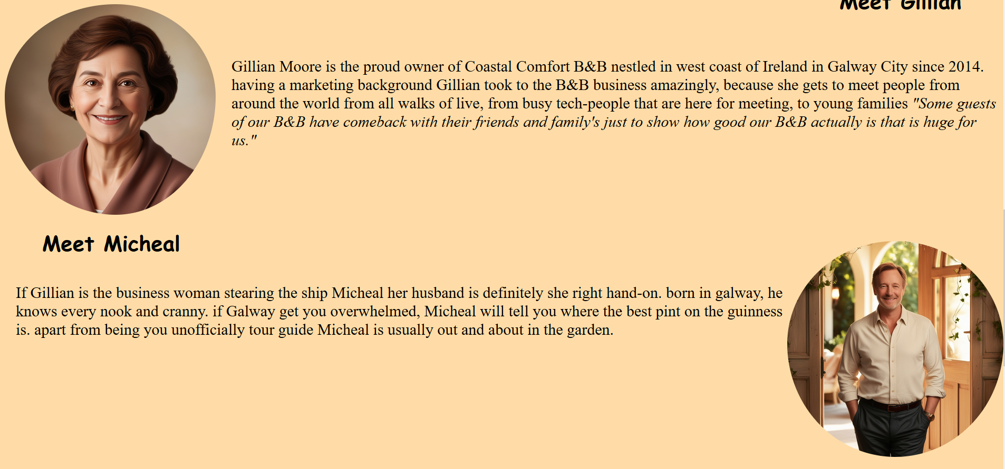

For this part of the About page, I used the same code as I used on the home page and just replaced the images and text on the page. I got these portraits from the internet and just rounded off the edges using border-radius at 50%;

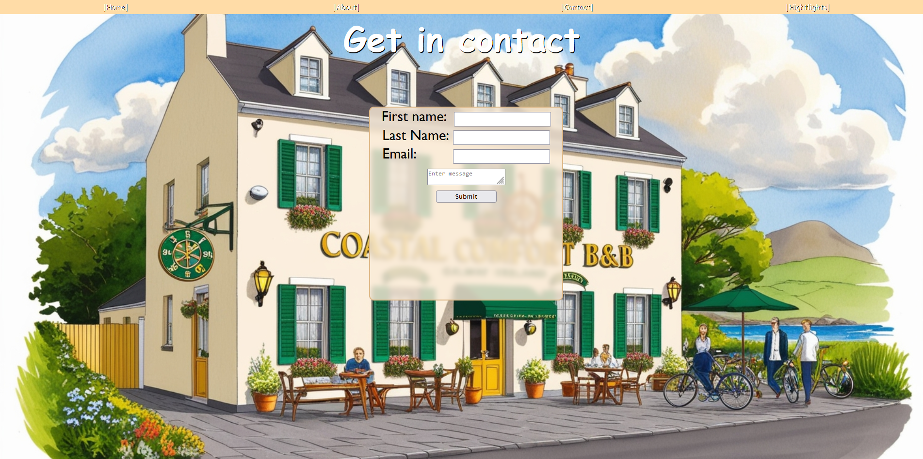

I learned from setting a background image on the last page and used the same code. The form needed input for First name, Last name, email, and a message box. I learned that you can make a glass-like div effect, I just wanted to see what it looked like and I liked it so much it stayed there. I think it’s a good effect.

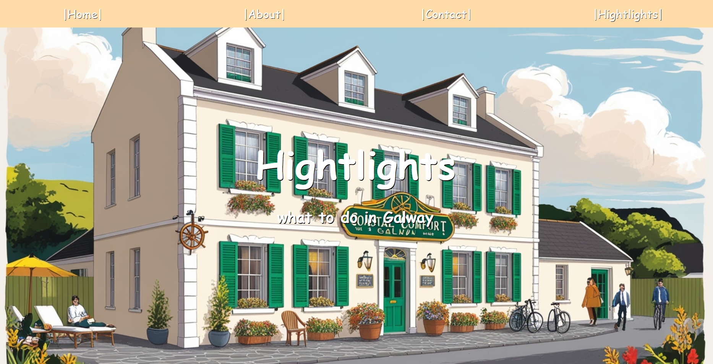

The Highlight page it highlights what to do in Galway, and it’s more of the same layout on the second and third pages using a background-image instead of the Home page, where I put it in a div.

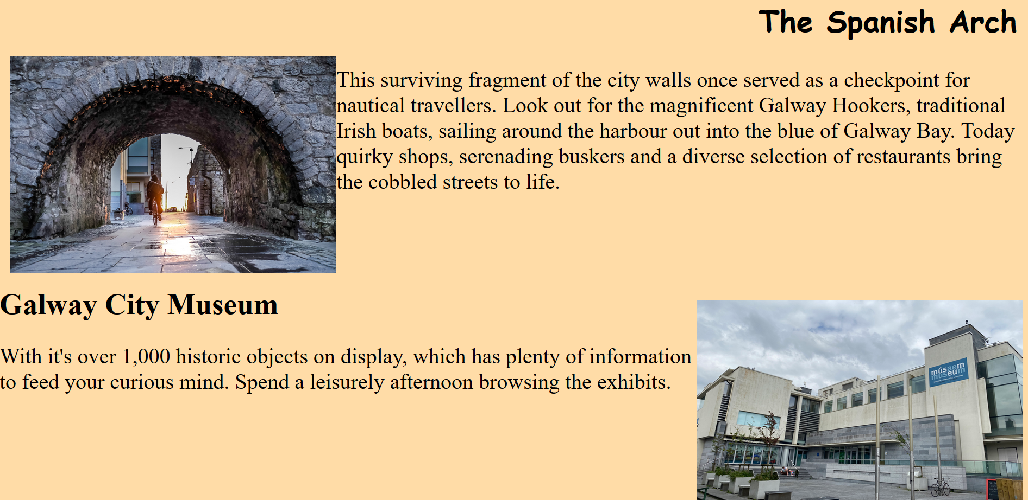

The same is true for these divs and text here. I just used the same code, which I did before and at the end of the page, too. I mentioned the Spanish Arch, Galway City Museum, and Waterways Walk as interesting things to do and see in Galway. I feel that they are the most interesting places to go.

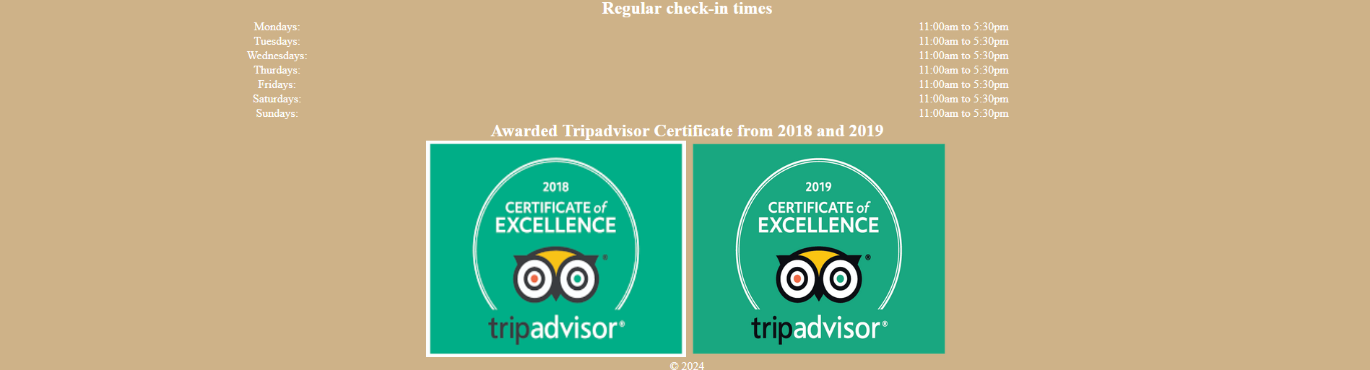

Every Page has the same footer, which increases the regular check-in times of 11 am to 5:30 PM, The B&B is aware from Tripadvisor from 2018 and 2019 also included is the address and a Copyright 2024.

Reflection   
  
Overall, I enjoyed this module. I think I did a decent job of pulling the website together. I fell at the JavaScript scripting. I understand that it is essential that I know, so I’ll need to do a lot in JavaScript to grasp that programming language better. Another thing that might raise a red flag is that every page has its own CSS file attached. My reasoning for that is that, for me, it was just for readability. I’m not the best reader, so I thought that if I tied every page to a CSS file, it would be much more manageable for me. That is not done in a professional environment, and there are a few issues with some bits of the layout that, if I had more time, I would fix. However, apart from some of the issues I stated, I really enjoyed it, and it’s given me a lot more to think about and what area I wish to get into after college has ended. Hopefully, I will make better and better websites in the future.